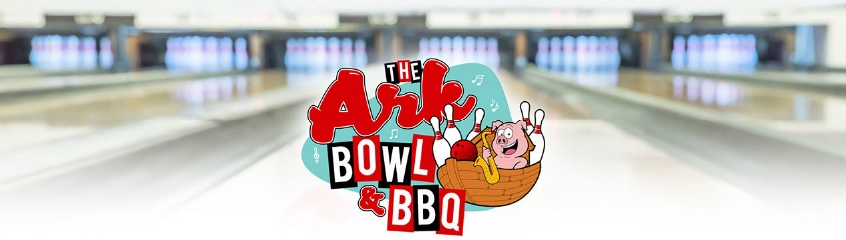
Our Menu changes from time to time due to availability,weather conditions and the state of mind our Cook is currently in -we also change our sides from time to time so double check:)

*Catskill “Big Mess” Poutine $12
-french fries, homemade 3-cheese drizzle & bacon brown gravy

*French Frie Boat $5
Add melted cheese $5
*Onion Ring Boat $5
Add melted cheese $5

*Smoked Beef Brisket Chili Bowl $12
w/cheddar cheese, sour cream & nachos
*Smoked Chicken Wings
6 wings $8 12 wings $16
-Carolina Tangy, Buffalo Hot, Nashville Hot, Memphis Sweet,
Garlic & Parmesan, Mississippi Honey & Esteban’s Barn Burnah
*Natty Nachos $16
w/smoked beef brisket chili, Mexican cheese, jalapenos & sour cream
*Tomato-Mozzarella-Sweet Basil Salad $12
w/ virgin olive oil & balsamic vinegar drizzle

*Smoked St. Louis Pork Ribs
Half Rack $19 Full Rack $30
w/ Mac n' Cheese & French fries

*Smoked Beef Brisket Sandwich $17
w/Mac n' Cheese & French Fries
*Boston Marinated Steak Tips $17
w/ Mac n' Cheese & French Fries
*Mama Mia Penne Pasta & Homemade Meatballs $15
w/ garlic bread
-70% beef brisket & 30% Boston butt pork mix
*Ham Steak Sandwich $15
w/American cheese, Blue Plate Horseradish Mayo & french fries
*Mojo Pulled Pork Corn Tortilla Tacos (3) $15
w/Pico de Gallo, Queso cheese, rice & beans

*Fried Atlantic Cod & Chips $15
w/french fries
Friday Only & Sometimes Saturday:)
*Fried Ipswich Scallop Plate $25
w/french fries
Friday Only & Sometimes Saturday
*Fried Ipswich Big Belly Clams $25
w/french fries
Friday Only & Sometimes Saturday
* The Ahhk 8oz. Angus Burgah w/ french fries $15
*add American or Swiss cheese $2
*Big Daddy’s Three-Cheese MAC Cast Iron Skillet $15
-add smoked beef brisket or Mojo pulled pork $6
*Nashville Hot Fried Chicken Sandwich $15
w/Blue Plate horseradish mayo, American cheese,
bacon, sweet red pepper, pickles & french fries
*Meatball Parmigiana Po’Boy $15
w/ cheddar cheese & french fries
-70% beef brisket & 30% Boston butt pork mix
*Charlie Say's Tuna Melt $13
w/ Blue Plate mayo, bacon,cheese, tomato w/french fries
-American or Swiss cheese-
*Grilled Cheese Deluxe w/ french fries $10
-American or Swiss Cheese-
-add Hot House Tomato $2
*Grilled Hot Diggity Dog w/ french fries $10
*Lots of Juices, Bottled Water, Seltzer, Soda & Smiles
-Ask Your Server What We Have Specifically-

